**Problem B - Jocas is spinning the head!**

**Description**

Jocas found a job at a company that develop games for android. As a novice, his first task is to create a new board game, but giving the possibility to the user of knowing the right sequence of moves that makes him win.

After some hours, Jocas finally found an interesting game. The idea consists of spinning the heads of rabbits in order to reach a specific pattern. There are four rabbits, placed in a 2 by 2 grid, which is initially scrambled. The final pattern (that we call the "target") corresponds to the following figure.

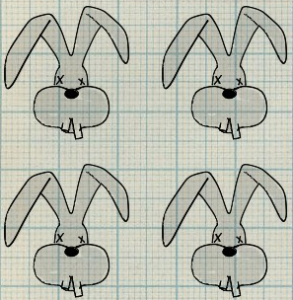

Each spin affects a column or a row, that is, two rabbits. There are four possible directions: left, right, up, down. The following two figures show some examples, where the first corresponds to a right spin in the 1st row, and the second to a up spin in the 2nd column.

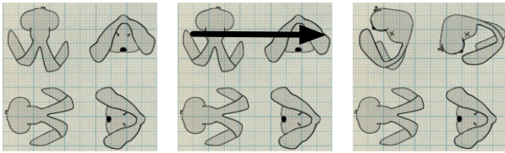

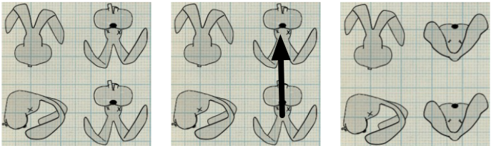

The following figure shows how to reach the target from an initial state: right direction in the 2nd row, followed by up direction in the 2nd column.

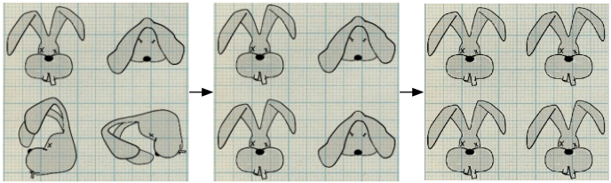

This seems to be easy for a programming novice, but now comes the hardest part: how to compute the shortest sequence of moves in the game that allows to reach the target?

**Task**

Given the initial state and the maximum number of spins allowed, the goal is to make a program that will determine the shortest sequence of spins that reach the target.

**Input**

Consider the following coding for each of the positionss of the rabbit head:

|  |  |
| --- | --- |
| Code | Head |
| 1 | C:\Users\Daniel\Desktop\126793188568.png |
| 2 | C:\Users\Daniel\Desktop\126793188568.png |
| 3 | C:\Users\Daniel\Desktop\126793188568.png |
| 4 | C:\Users\Daniel\Desktop\126793188568.png |
| 5 | C:\Users\Daniel\Desktop\126793188568.png |
| 6 | C:\Users\Daniel\Desktop\126793188568.png |
| 7 | C:\Users\Daniel\Desktop\126793188568.png |
| 8 | C:\Users\Daniel\Desktop\126793188568.png |
| 9 | C:\Users\Daniel\Desktop\126793188568.png |
| 10 | C:\Users\Daniel\Desktop\126793188568.png |
| 11 | C:\Users\Daniel\Desktop\126793188568.png |
| 12 | C:\Users\Daniel\Desktop\126793188568.png |
| 13 | C:\Users\Daniel\Desktop\126793188568.png |
| 14 | C:\Users\Daniel\Desktop\126793188568.png |
| 15 | C:\Users\Daniel\Desktop\126793188568.png |
| 16 | C:\Users\Daniel\Desktop\126793188568.png |
| 17 | C:\Users\Daniel\Desktop\126793188568.png |
| 18 | C:\Users\Daniel\Desktop\126793188568.png |
| 19 | C:\Users\Daniel\Desktop\126793188568.png |
| 20 | C:\Users\Daniel\Desktop\126793188568.png |
| 21 | C:\Users\Daniel\Desktop\126793188568.png |
| 22 | C:\Users\Daniel\Desktop\126793188568.png |
| 23 | C:\Users\Daniel\Desktop\126793188568.png |
| 24 | C:\Users\Daniel\Desktop\126793188568.png |

Note that positions 6, 16, 19 and 21 are the "neck view" (the rabbit head is seen from below).

The first line contains one integer: the maximum number of spins (*n*). Then, 2 lines follow, each with 2 integers describing the initial state.

**Output**

For each test case, print the shortest sequence of moves to reach the target in a single line. Each spin is coded with a letter, indicating the spinning direction (R=right; L=left; U=up; D=down) and a number, indicating the column (if spin is U or D) or the row (if spin is R or L).

Since there may be more than one shortest sequence, the program should choose the one that is lexicographically smaller (means that D1 < D2 < L1 < L2 < R1 < R2 < U1 < U2).

**Constraints**

* *n ≤ 5*

**Example**

**Example input:**

4

1 17

13 20

**Example output:**

R2 U2